CHO column for 12/16/21 (550 words)

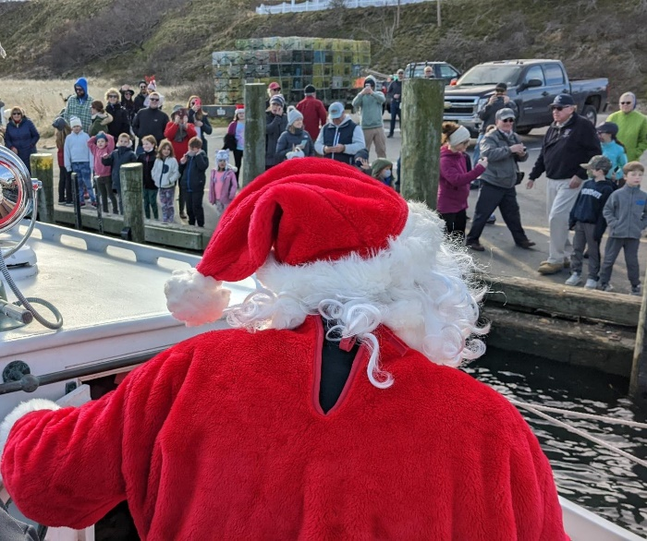

Guests enjoy the CHO’s Grand Opening and Auctions event Dec. 1 (left); Children eagerly await Santa’s arrival in Chatham on Dec. 4 aboard the CHO’s CG36500 lifeboat (Marcia Bromley photo).

**CLOSED, RE-OPENED AND IN-BETWEEN;**

**2021 WAS A YEAR OF CONTRASTS FOR THE CHO**

**A year-end review by Jay Stradal, CHO Board Chair**

It began with only virtual meetings and events in the midst of a post-holiday COVID spike on the Cape, yet it ended with re-opened facilities and people anxious to get back together—albeit with proper health precautions. The year 2021 was certainly one of contrasts and perseverance at the Centers for Culture and History in Orleans (the CHO).

Building on momentum from the previous year, we focused on producing more online programming during the winter and spring. History talks, concerts and tours were added to the nearly 30 videos we had already posted on our YouTube channel [youtube.com/user/Orleanshs/videos]. At the same time, we began planning for an in-person reopening celebration with outdoor music at our Meetinghouse Museum in the hope of reconnecting with members and guests.

That mid-June outside event was well attended. People self-distanced while they ate their picnic lunches and wore masks as they listened to the live performance. In contrast, we found that guests were reluctant to go inside the Meetinghouse to see “The Land Called Nawsett” exhibition because of lingering pandemic concerns.

Meanwhile, we needed to find another covered space to do the annual maintenance on our CG 36500 lifeboat since the boathouse at Coast Guard Station Chatham was still closed to civilians. Volunteers needed room to social-distance as they scraped, sanded and painted the hull and readied the boat for the summer season. Fortunately, the Orleans Department of Public Works allowed us to use their old truck maintenance facility. Here, in another contrast, Coast Guard service members and auxiliary cadets came to us to assist, rather than us going to them.

In the late summer and fall months, as COVID vaccinations expanded, the pace of indoor history talks, concerts and other events increased as people became more comfortable with indoor events. We offered a wider variety of topics and music genres, again with the intent of reconnecting with the community. Some things were more popular than others, but at least the word was out that the CHO was back open.

Also, as the year progressed, word was spreading that our recently updated Meetinghouse and nearly completed Hurd Chapel spaces were available to rent for community and private use. We heard from a future bride looking for a wedding venue, a local music studio needing a place for student recitals and concerts, and area non-profits without a “home” looking for a meeting location. Not all worked out, yet in contrast to empty spaces at the beginning of the year, our vision of creating gathering places for CHO, community and private events was coming to fruition.

Most encouraging of all were two events earlier this month. On December 1, nearly 70 guests joined us in celebrating the completion of our $1.2 million building improvement projects and in bidding for items in both live and silent auctions—raising nearly $25,000 for new programs. Three days later, the CG36500 safely delivered Santa to the Chatham Fish Pier where some 200 children were eagerly awaiting his arrival.

The exuberance and holiday spirit of people at both events were in stark contrast to the pandemic-weary mood felt by most in early 2021. We are excited about the potential of the new year and look forward to more community gatherings and activities, while taking necessary health precautions. Happy holidays to all!

# # #